





Date: 22nd Jan 2024

Paresh Kumar Nayak

Minutes of Meeting

## Meeting Information

|  |  |  |  |  |  |
| --- | --- | --- | --- | --- | --- |
| **Meeting Name** | PEB Session on PIS, PES,QIF & CIF - Understanding Current Processes and System Functionality | | | **Prepared** **By** | Mastek Team |
| **Date of the Meeting** | 22 & 23 Jan 2024 | **Time** | 3:00PM to 5:00PM KSA | **Location** | PEB Site Sales Conference Room |
| **Meeting Purpose** | PEB Session on PIS, PES,QIF & CIF - Understanding Current Processes and System Functionality | | | | |
| **Meeting Leader** | Paresh Kumar Nayak | | | | |

## Attendees

|  |  |  |
| --- | --- | --- |
| **Sr No** | **Company** | **Name** |
| 1 | Zamil | Edison Garvida / ZSS Dammam Sales |
| 2 | zamil | Yunus Nasser / ZS Saudi PEB Engineering |
| 3 | zamil | Mohammed Towailib |
| 4 | zamil | Mohammed Fayazuddin |
| 5 | Mastek | Satish Chauhan |
| 6 | Mastek | Mohit Sahni |
| 7 | Mastek | Vivek Mishra |
| 8 | Mastek | Kushal Rami |
| 9 | Mastek | Akhilesh arun |
| 10 | Mastek | Nirmal Choudhary |
| 11 | Mastek | Uday Maguluri |
| 12 | Mastek | Paresh Kumar Nayak |
| 13 | Mastek | Avesh Gonodwala |
| 14 | Mastek | Rupesh Kulkarni |

## Objective of Meeting

### The objective of this meeting was to discuss and system demo for PEB Sales Systems PIS, PES, QIF & CIF.

## Discussion points and Business process understanding

* The first step of QIF is with account tab. Sales team will create the account.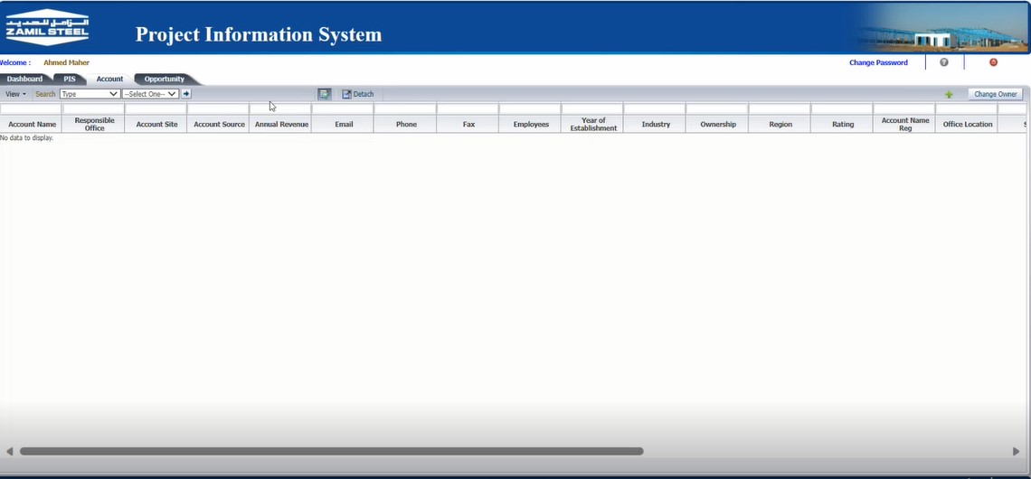
* Customer information is filled in the account tab.

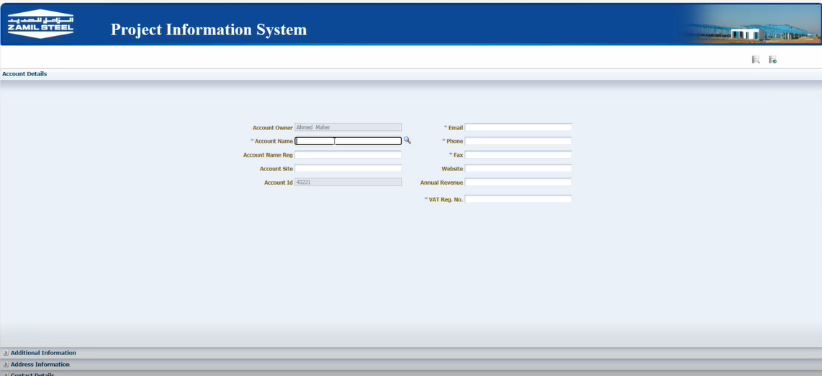

* After Account, then the Opportunity is created. Here the Proposal Number is auto generated by system.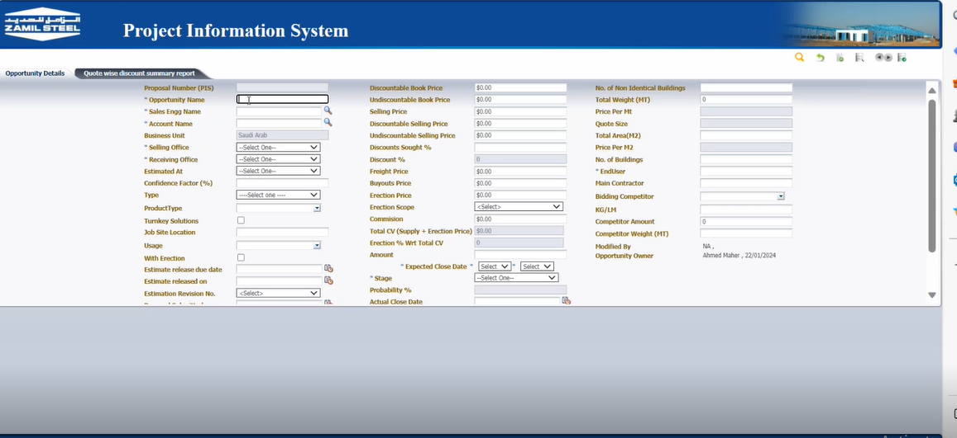
* Once the Opportunity is created then A job number will be generated by system. This is How a Quation looks after the opportunity is created.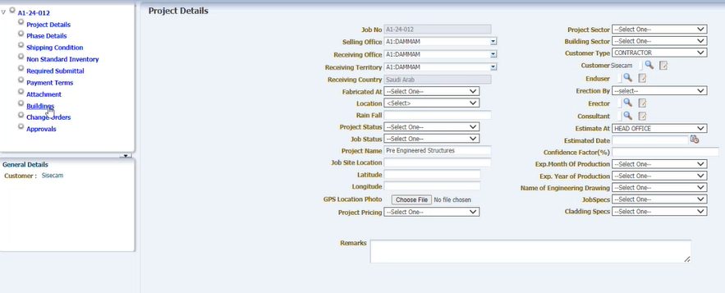
* In the Buildings section by click in the new record the output of PIS(X) is attached. 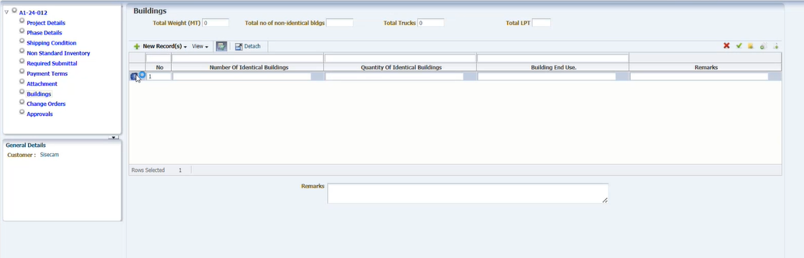
* This is the PIS(X) screen which contains all the technical information about the building. 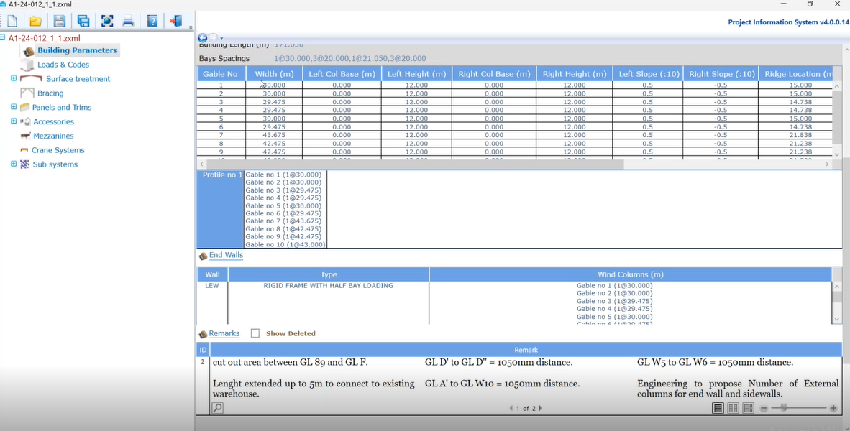

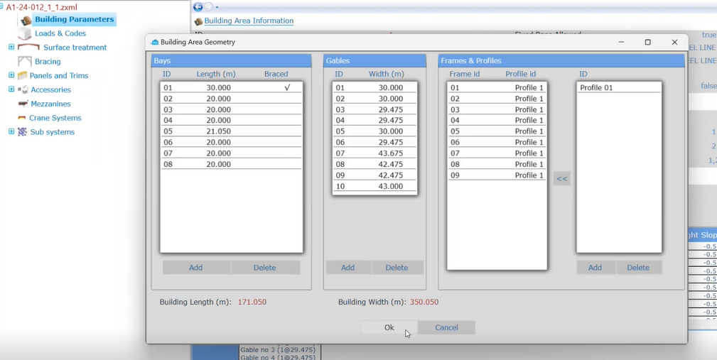

* After Uploading the PIS(X) output in PIS web then they save the form and sends a pdf of this form to Engineer team.
* Then the engineering team will receive a QIF through email notification.
* Engineering team start working on the Quotation module.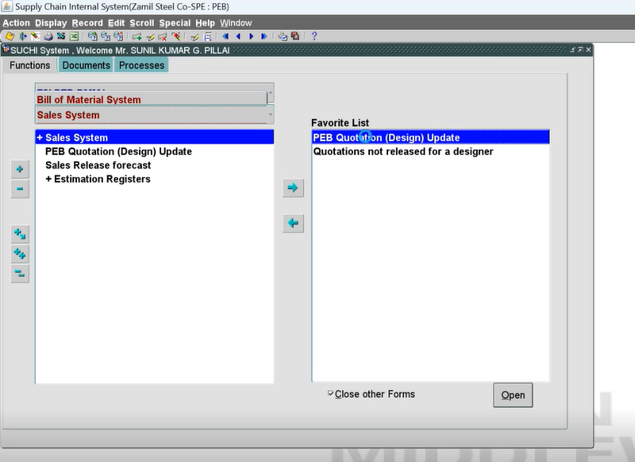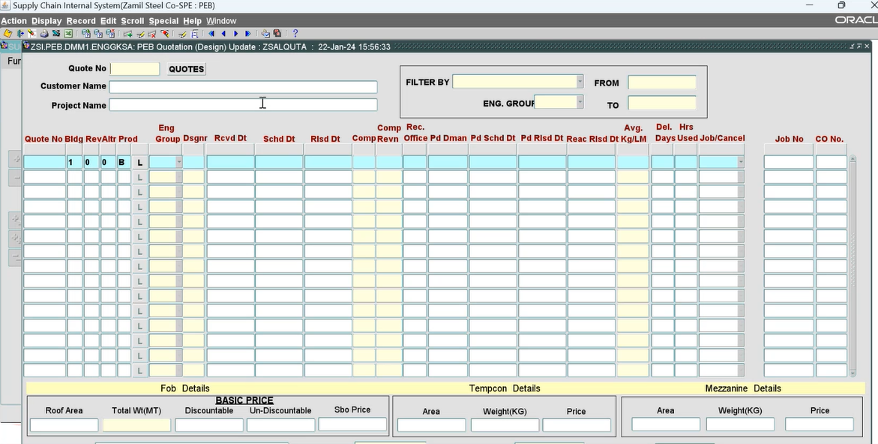

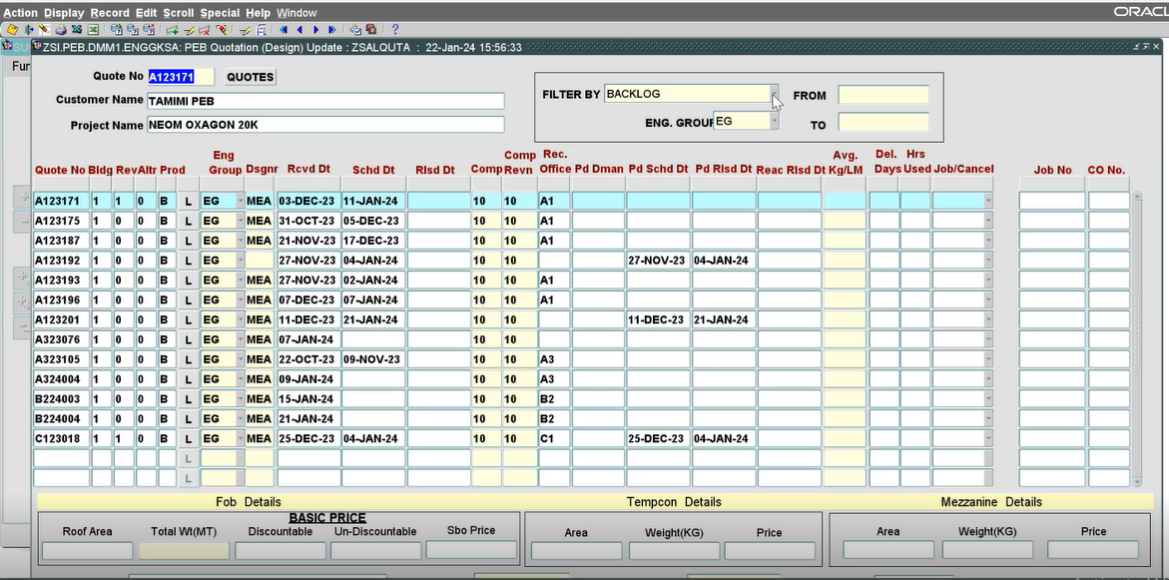

After the design, PIS, and customer drawing- then estimation comes to picture.

After the final designing engineering team will make the pricing in PES.

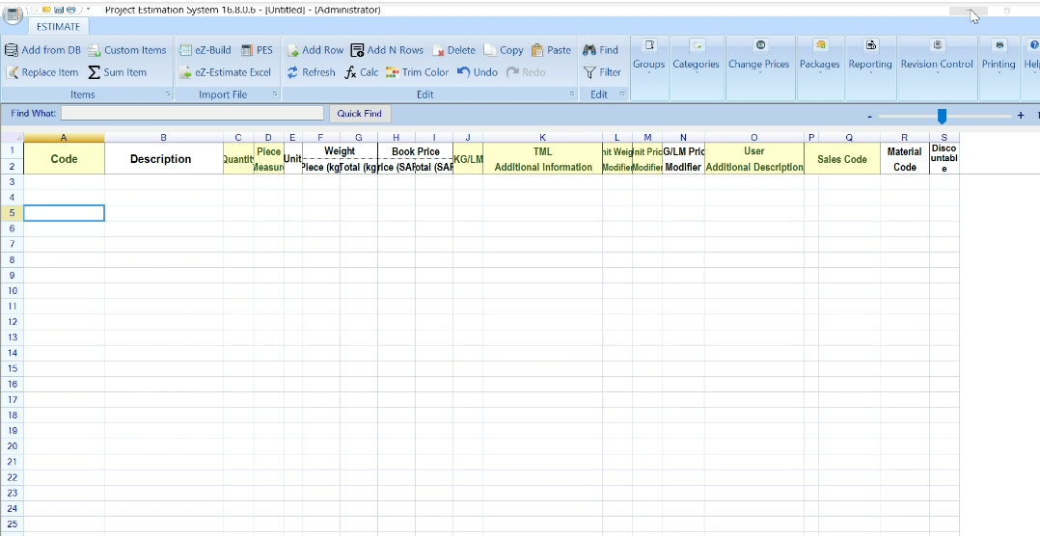

ASFAD (Drawing Software output) tml file will be uploaded in PES for further pricing.

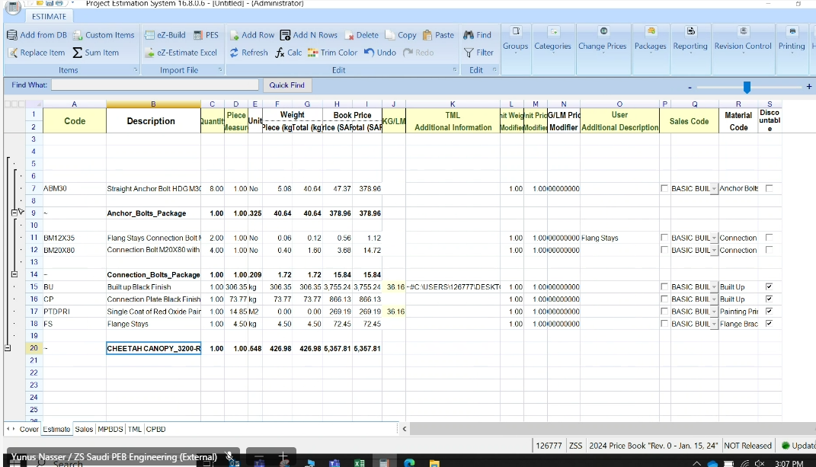

sometime for simple item like beam they can manually build the estimate in PES.

for special item they can estimate by putting the item and code.

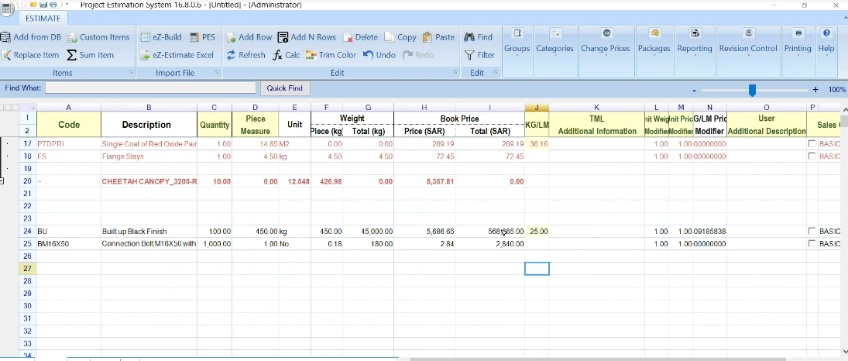

For standard item the category is already defined. For special item they manually add the category

They can upload the packages.

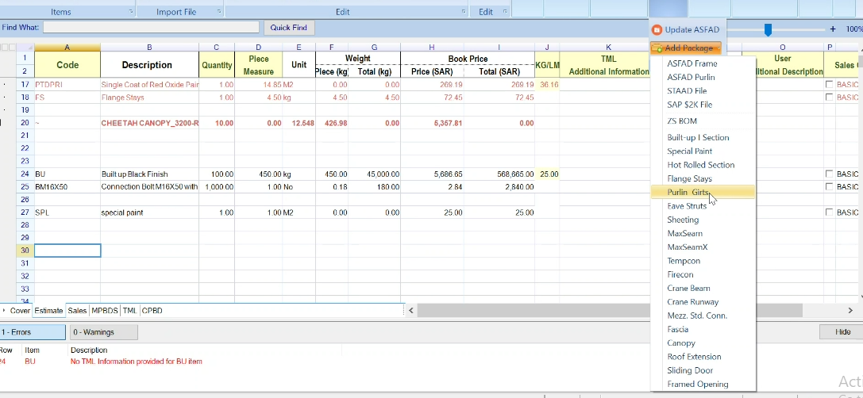

For custom item they will manually select the code

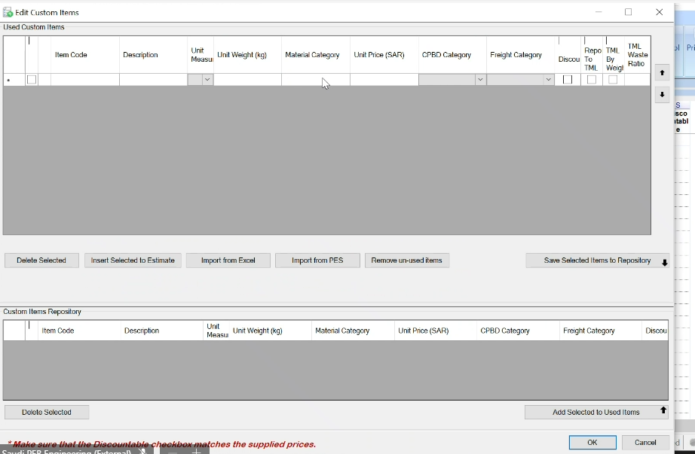

Coverpage/summery of project

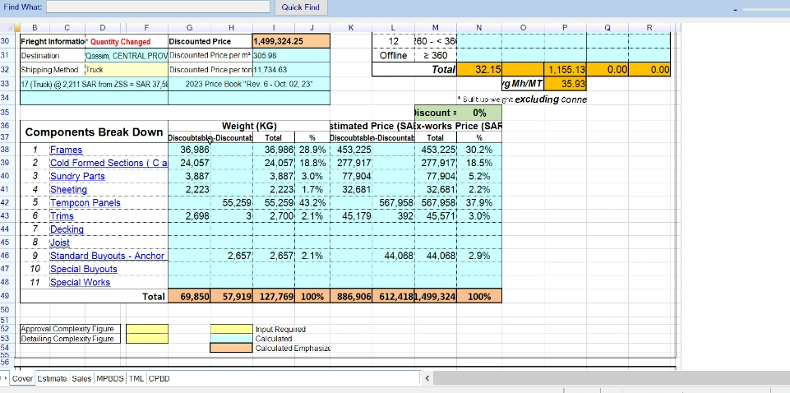

Breakdown details of each component that are already defined.

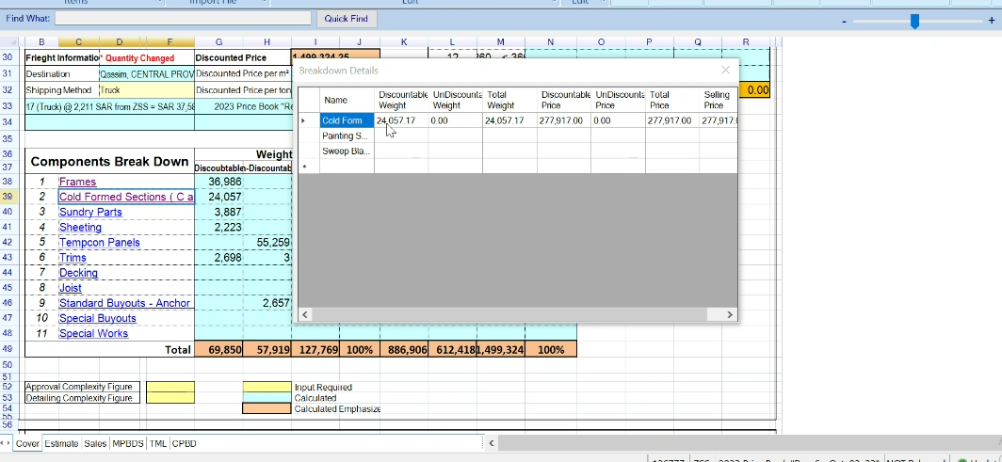

There is a database for freight calculation.

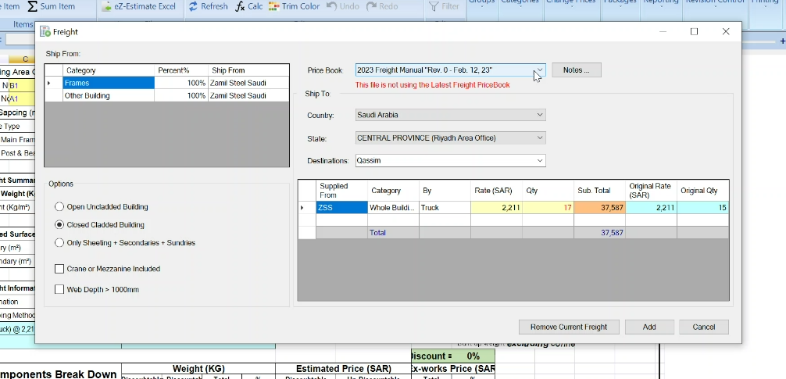

Pricebook database

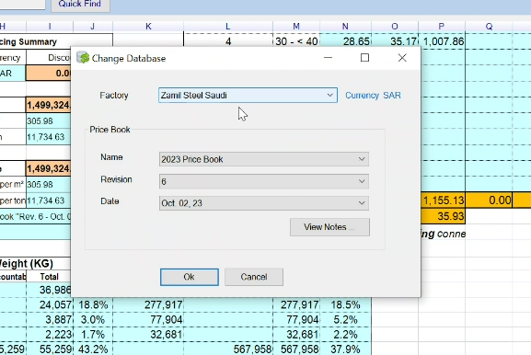

Terms and condition general assumption

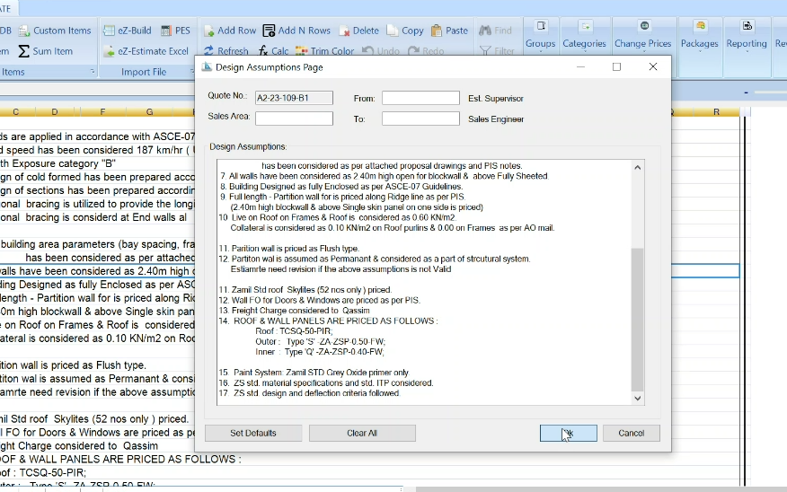

Sales breakdown summery

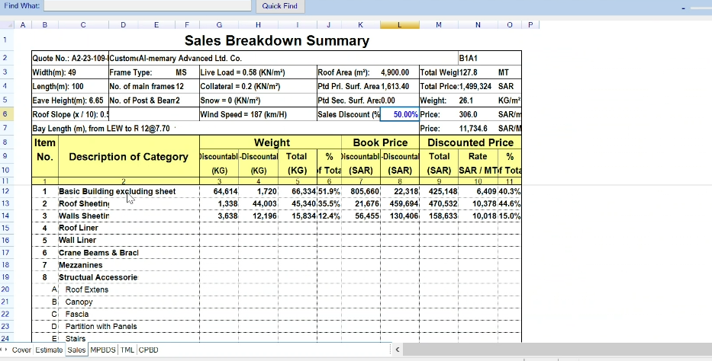

This is the Material Breakdown based on the Material category.

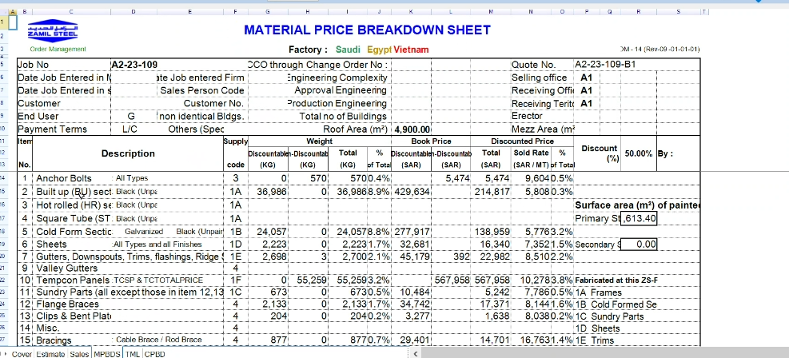

Once the final JOB awarded then they send the final estimate to OMD. This is the Tml-Tentative material list. Engineering will send this tml file to procurement team by exporting as text file and uploaded to SUCHI.

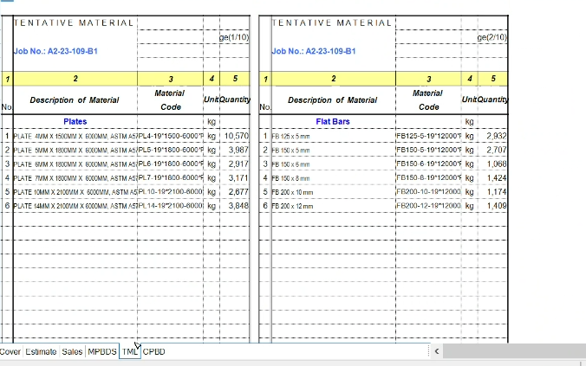

Estimates Price is of two parts- Discountable and non-discountable price. The non-discountable is Special Buyout item. The header level discount will only applicable only to Discountable items at each level.

Before signing the contract, the JAF is float where the approval is required from Internal management on certain percentage and if management reject the Approvals, then there will no Signing of contract.

JAF- in iSweet

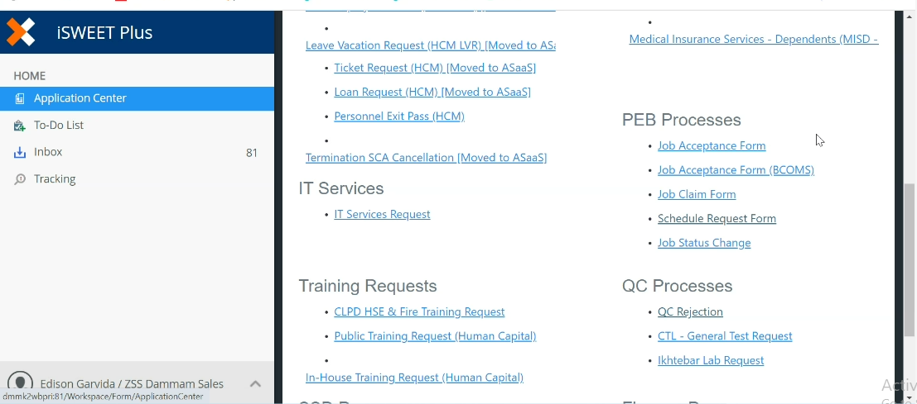

Fill all the details Quotation number and Job Number

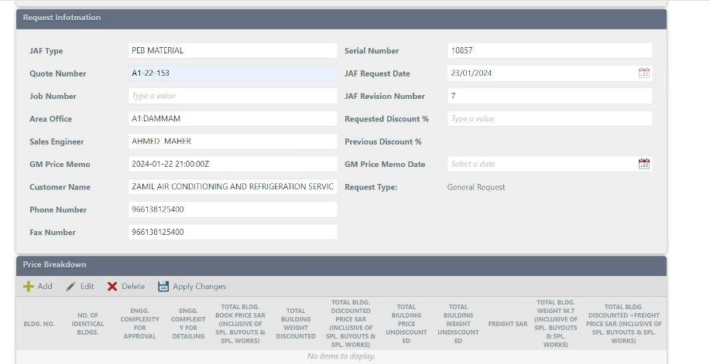

Price breakdown in JAF here comes from the estimates

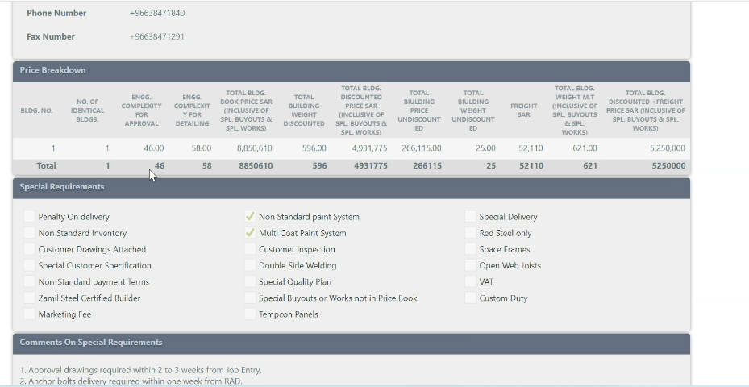

Special requirement needs to be cheked whereever possible

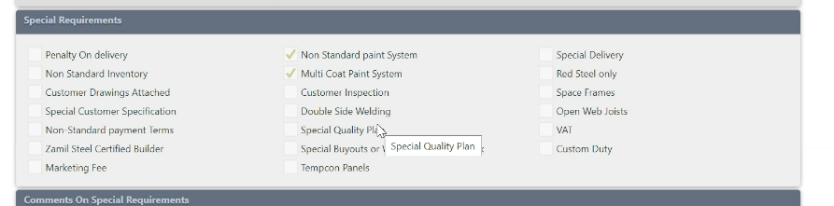

Special requirement needs are there in JAF.

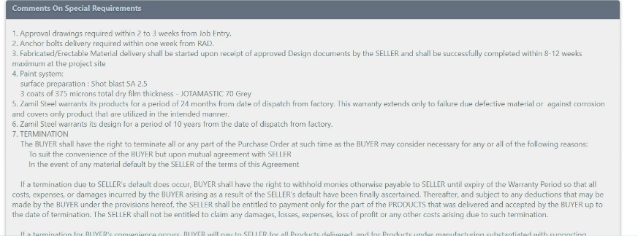

Then depending on the discount percentage, the form will go to the respective people for approval.

QIF – CIF Conversion

Search with the Job number in PIS

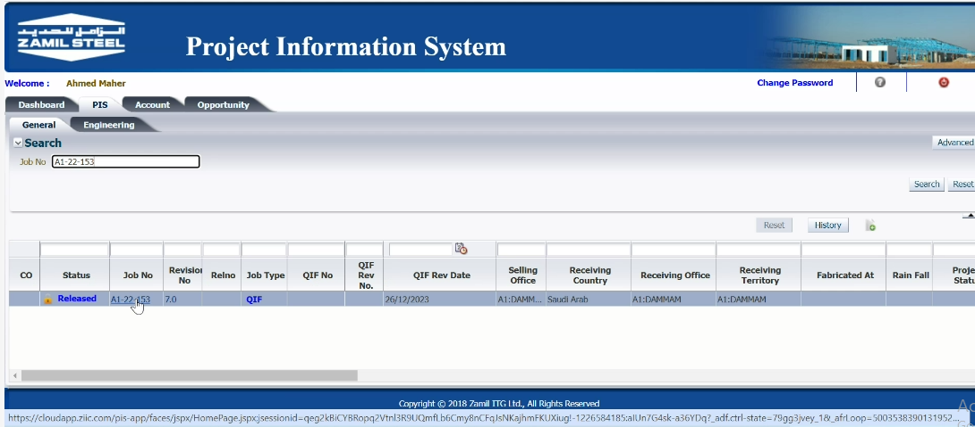

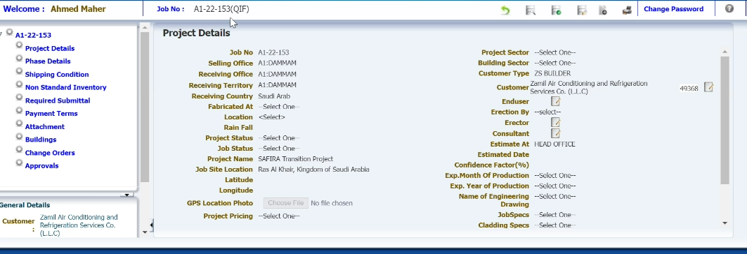

Click on the button then QIF will be converted to CIF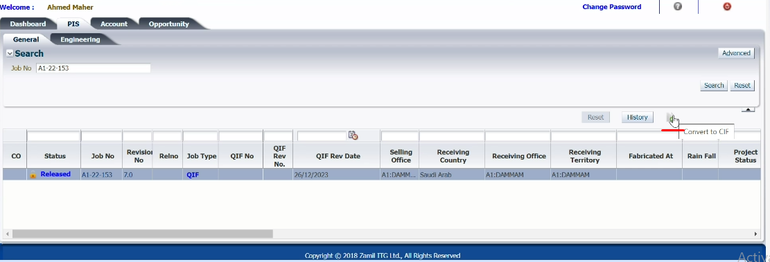

After the conversion a Job number will be generated. This is the CIF screen.

